Dormitory Management Database System

Presentation Group 23

Group Members:
• Oğuzhan Çakal 290201021
• Arda Hondoroğlu 290201015
• Abdullah Semih Çetin 290201093
• Sinan İnce 290201018
• Sercan Utku Temelci 290201087

PROJECT OVERVIEW
The Dormitory Management System Database is designed to support the core operational needs of a university dormitory. The system centralizes information related to students, rooms, staff, maintenance operations, dining hall activities, visitors, and financial transactions.
The primary goal of the project is to design and implement a relational database that ensures data consistency, reduces redundancy, and supports efficient querying for daily dormitory operations.
PURPOSE OF THE SYSTEM
The purpose of this database system is to provide an organized and reliable platform for managing dormitory-related data.
Specifically, the system aims to:
- Track student accommodation and room occupancy accurately
- Support operational workflows such as maintenance and dining services
- Record visitor information for security purposes
- Manage financial processes including billing, student payments, and staff salaries
- Enable administrators to access meaningful information through queries and reports

System Users

User Roles and Responsibilities
Dormitory Manager
- Oversees room assignments and occupancy levels
- Manages dormitory staff and operational workflows
Maintenance Staff
- Performs maintenance and cleaning tasks
- Records completed tasks and logs used supplies
Dining Hall Staff
- Records daily dining hall operations
- Manages meal schedules and menus
Security Officer
- Registers visitors entering the dormitory
- Monitors visit history for security purposes
Student
- Views room assignment information
- Views billing and payment history
Accounting Officer
- Manages student billing and payments
- Handles staff salary payments and payroll records
System Administrator
- Maintains database integrity
- Manages system access and permissions

Constraints Implemented
Primary Keys
- All main entities use single-column primary keys
(e.g., Student_ID, Room_ID, Staff_ID, Bill_ID)
- Relationship tables use composite primary keys
(e.g., ASSIGNED_TO(Student_ID, Room_ID), VISITS(Visitor_ID, Student_ID, Visit_Date, Visit_Time))
Foreign Keys
- Referential integrity is enforced between related entities, such as:
  - ASSIGNED_TO.Student_ID → STUDENT
  - ASSIGNED_TO.Room_ID → ROOM
  - BILLING.Student_ID → STUDENT
  - PAYMENT.Student_ID → STUDENT
  - STAFF_PAYMENT.Staff_ID → STAFF
  - Dining, maintenance, and supply relations are enforced via foreign keys.
NOT NULL Constraints
Applied to mandatory attributes:
- Names and roles (First_Name, Last_Name, Role)
- Critical dates (Billing_Date, Payment_Date)
- Core identifiers such as Room_Number and Department
UNIQUE Constraints
- STUDENT: Email, Phone_Number
- STAFF: Email, Phone_Number
Ensures unique contact information while allowing NULL values (Oracle behavior).
CHECK Constraints
- ROOM.Capacity IN (3,4,5)
- Monetary values must be positive:
  - Salary > 0
  - Billing.Amount > 0
  - Payment.Amount_Paid > 0
  - Staff_Payment.Amount > 0
ASSUMPTIONS
The following assumptions were made during the design of the system:
- Each student is assigned to at most one room at a given time.
- Rooms have fixed capacities of 3, 4, or 5 students.
- Billing is generated on a monthly basis.
- A student may make multiple payments over time.
- Staff members may receive multiple salary payments.
- Dining hall operations are recorded daily and categorized by meal type.
- Visitor records are maintained for security and monitoring purposes.
These assumptions simplify system design while maintaining realistic operational behavior.

REQUIREMENTS

The database system is designed to fulfill the following functional requirements:
- Maintaining detailed records of students residing in the dormitory.
- Managing room information, capacities, and student assignments.
- Keeping track of dormitory staff and their assigned duties.
- Recording visitor information and visit logs.
- Scheduling and logging maintenance and cleaning tasks.
- Managing dormitory supplies and tracking their usage.
- Managing dining hall operations, meals, and daily menus.
- Handling student billing, payments, and staff salary payments.
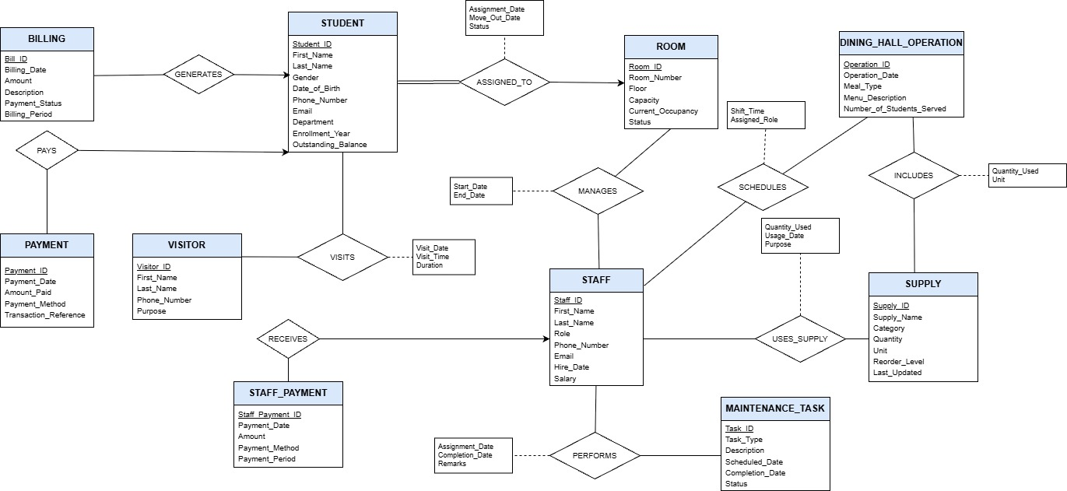
ER DIAGRAM

Relational Schema
1.ROOM( Room_ID PRIMARY KEY, Room_Number, Floor, Capacity, Current_Occupancy, Status )
2.STUDENT( Student_ID PRIMARY KEY, First_Name, Last_Name, Gender, Date_of_Birth, Phone_Number, Email, Department, Enrollment_Year, Outstanding_Balance )
3.STAFF( Staff_ID PRIMARY KEY, First_Name, Last_Name, Role, Phone_Number, Email, Hire_Date, Salary )
4.ASSIGNED_TO( Student_ID FK→STUDENT, Room_ID FK→ROOM, Assignment_Date, Move_Out_Date, Status, PRIMARY KEY (Student_ID, Room_ID) )
5.MAINTENANCE_TASK( Task_ID PRIMARY KEY, Task_Type, Description, Room_ID FK→ROOM, Scheduled_Date, Completion_Date, Status )
6.PERFORMS( Staff_ID FK→STAFF, Task_ID FK→MAINTENANCE_TASK, Assigned_Date, Completion_Date, Remarks, PRIMARY KEY (Staff_ID, Task_ID) )
7.VISITOR( Visitor_ID PRIMARY KEY, First_Name, Last_Name, Phone_Number, Purpose )
8.VISITS( Visitor_ID FK→VISITOR, Student_ID FK→STUDENT, Visit_Date, Visit_Time, Duration, PRIMARY KEY (Visitor_ID, Student_ID, Visit_Date, Visit_Time) )
9.BILLING( Bill_ID PRIMARY KEY, Student_ID FK→STUDENT, Billing_Date, Amount, Description, Payment_Status, Billing_Period )
10.PAYMENT( Payment_ID PRIMARY KEY, Student_ID FK→STUDENT, Payment_Date, Amount_Paid, Payment_Method, Transaction_Reference )
11.STAFF_PAYMENT( Staff_Payment_ID PRIMARY KEY, Staff_ID FK→STAFF, Payment_Date, Amount, Payment_Method, Payment_Period )
12.SUPPLY( Supply_ID PRIMARY KEY, Supply_Name, Category, Quantity, Unit, Reorder_Level, Last_Updated )
13.DINING_HALL_OPERATION( Operation_ID PRIMARY KEY, Operation_Date, Meal_Type, Menu_Description, Number_of_Students_Served )
14.USES_SUPPLY( Staff_ID FK→STAFF, Supply_ID FK→SUPPLY, Quantity_Used, Usage_Date, Purpose, PRIMARY KEY (Staff_ID, Supply_ID, Usage_Date) )
15.INCLUDES( Operation_ID FK→DINING_HALL_OPERATION, Supply_ID FK→SUPPLY, Quantity_Used, Unit, PRIMARY KEY (Operation_ID, Supply_ID) )
16.SCHEDULES( Staff_ID FK→STAFF, Operation_ID FK→DINING_HALL_OPERATION, Shift_Time, Assigned_Role, PRIMARY KEY (Staff_ID, Operation_ID) )
17.MANAGES( Staff_ID FK→STAFF, Room_ID FK→ROOM, Start_Date, End_Date, PRIMARY KEY (Staff_ID, Room_ID) )

Database script creation and population
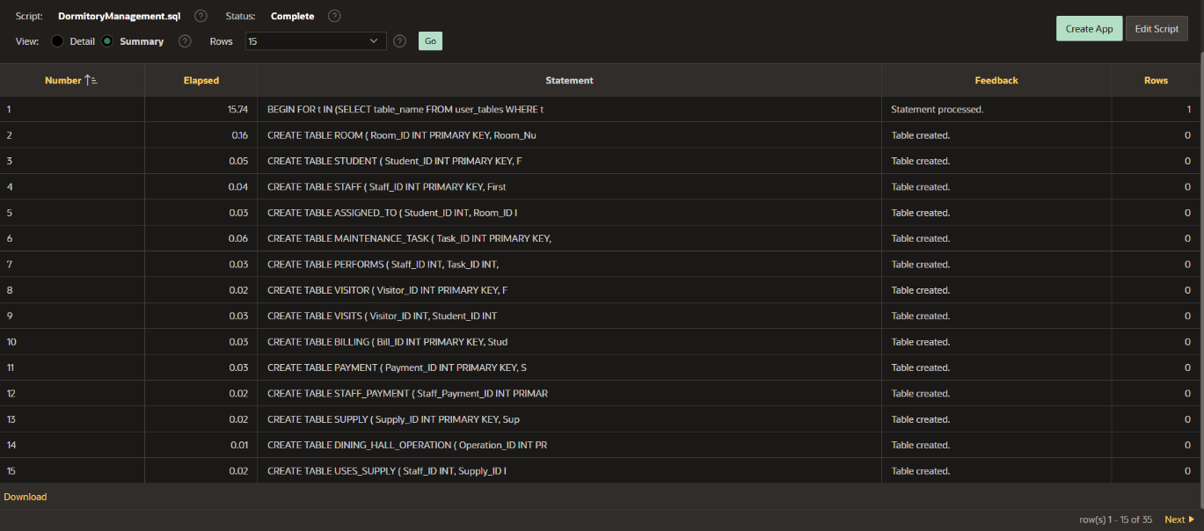
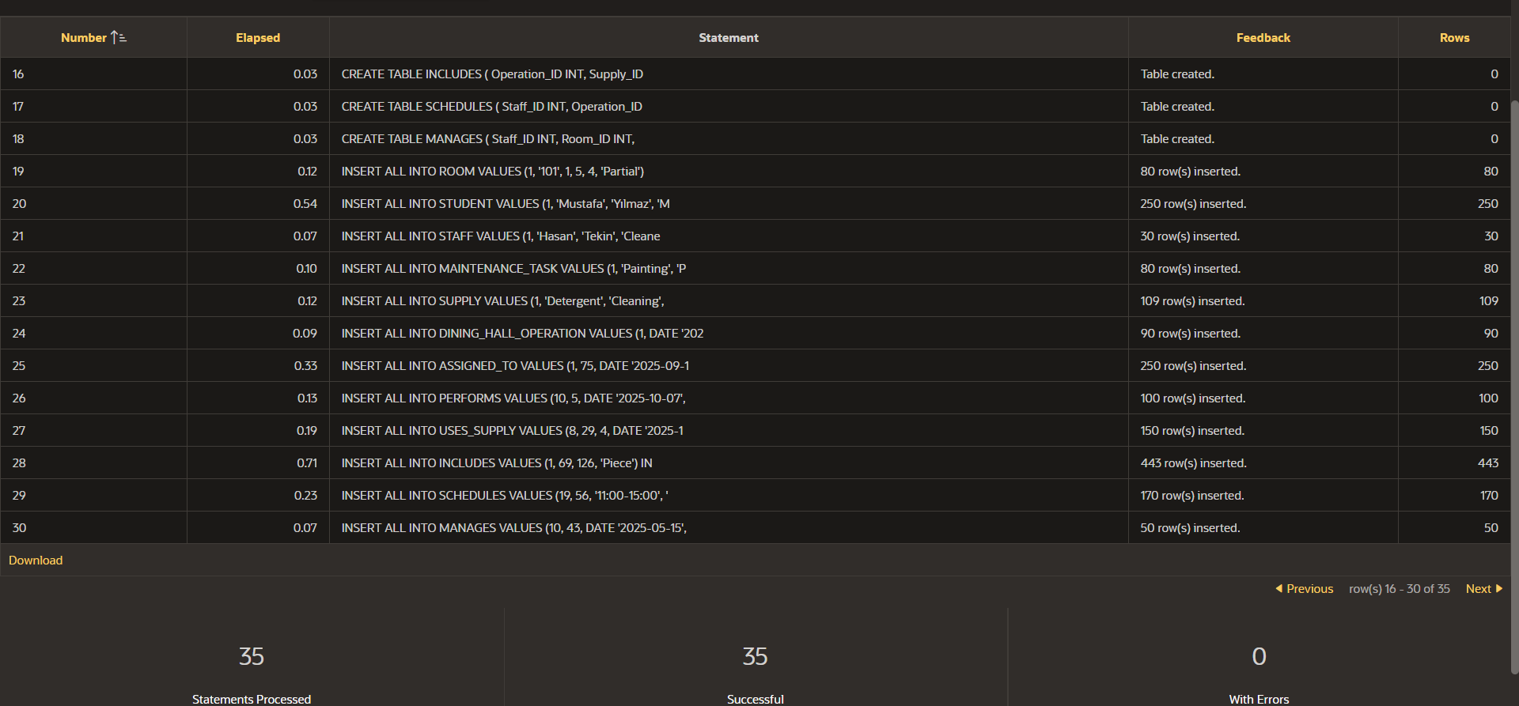
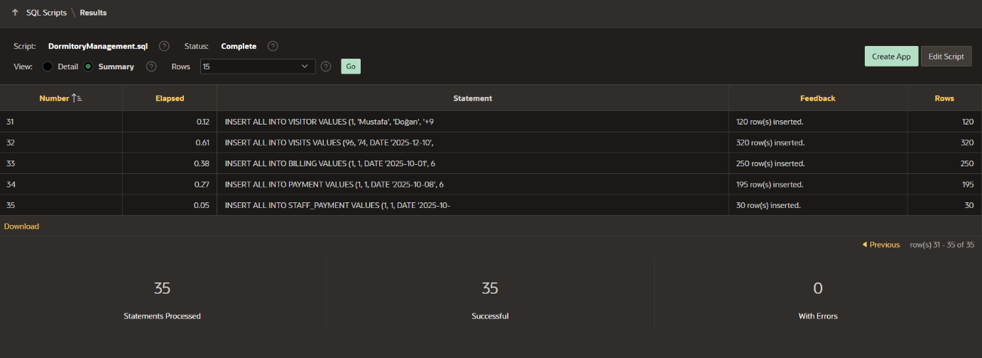
The database schema and data population scripts were executed successfully without any errors.

Query 1)
Available Beds per Room
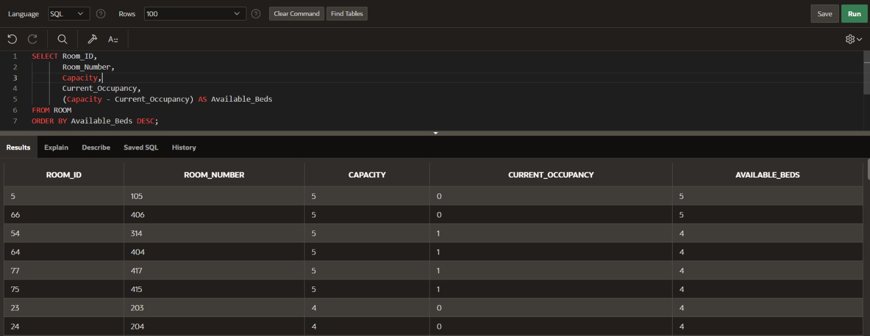
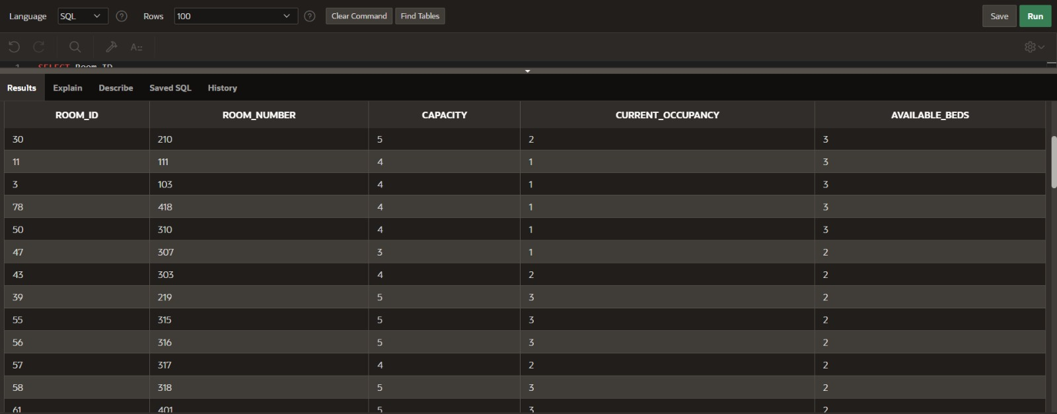
This query calculates the number of available beds in each room by subtracting current occupancy from capacity and orders the rooms to prioritize those with the highest availability.

Query 2)
Displaying the daily menus
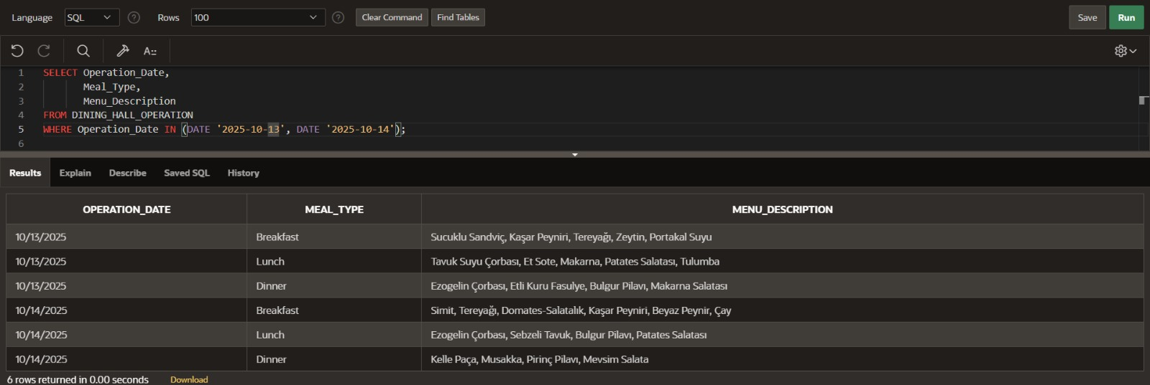
This query retrieves the dining hall menus for selected dates by listing meal types and their corresponding menu descriptions, allowing daily meal planning to be reviewed easily.
Query 3)
Displaying the students with unpaid bills
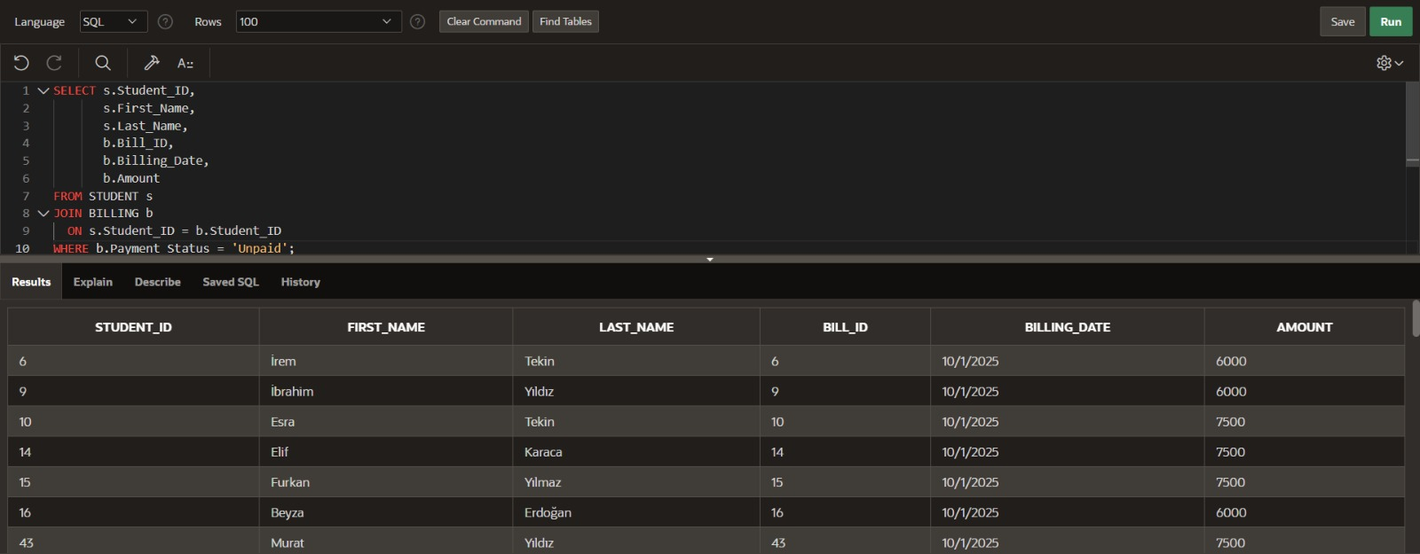
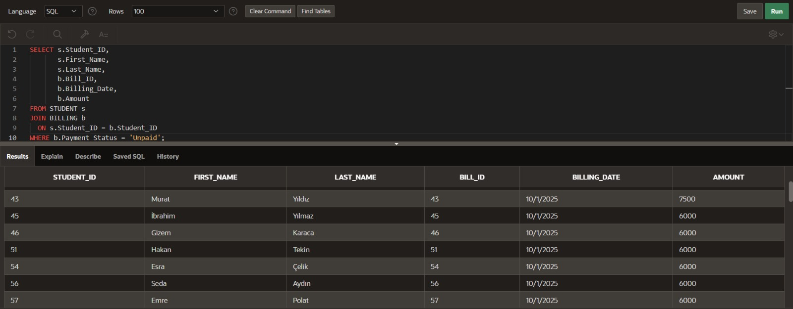
This query lists students with unpaid bills by joining student and billing records, displaying billing dates and amounts to support effective payment tracking.
Query 4)
Room-Based Maintenance History
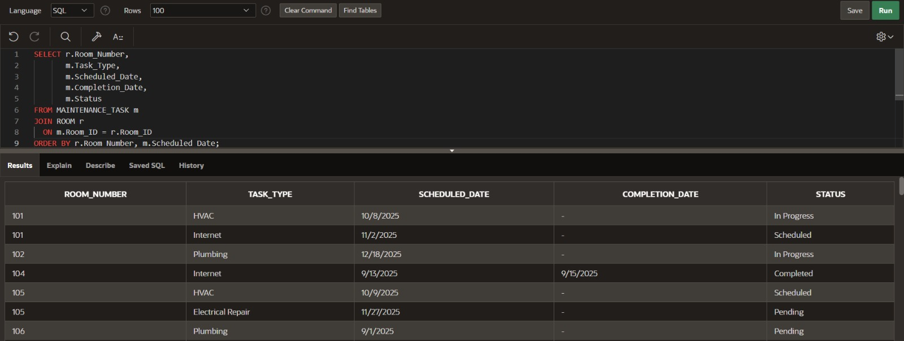
This query lists maintenance tasks by room, showing task types, scheduled and completion dates, and current status to monitor maintenance activities effectively.

Query 5)
Number of the completed maintenance tasks per employee
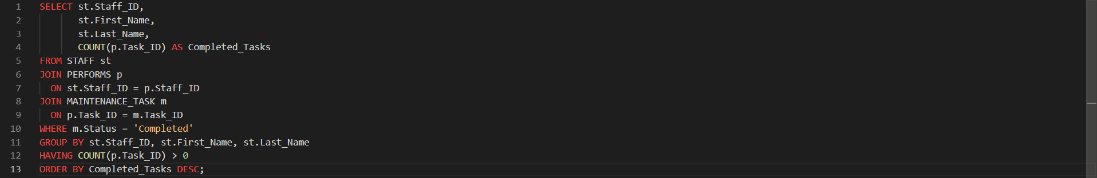
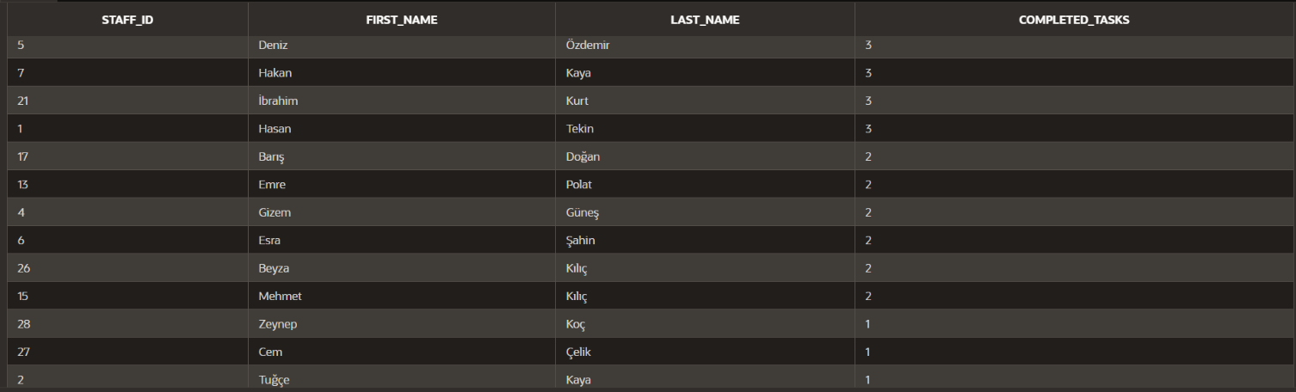
This query analyzes staff performance by counting the number of completed maintenance tasks per staff member.

Conclusion
This project presents a complete Dormitory Management System Database that supports accommodation, staff operations, maintenance, dining services, visitor tracking, and financial processes. The system was designed using an ER model and implemented as a consistent relational schema in Oracle SQL.
Data integrity is ensured through primary and foreign keys, along with selected NOT NULL, UNIQUE, and CHECK constraints. The database was successfully created, populated with realistic data, and validated using fundamental queries, resulting in a reliable and extensible solution.

